Fatima Jinnah Women University

*Department of Software Engineering*



**SUBJECT: CC LAB**

**SUBMITTED TO: SIR SHOAIB**

**SUBMITTED BY: ZUNAIRA NOOR**

**REGISTRATION NO: 2023-BSE-075**

**SEMESTER: V-B**

**Task 1 – Switch to root with su - and back to a normal user**

Goal: Demonstrate switching to the root account using su - and exiting back to your normal user.

1. Set a root password (Ubuntu root is disabled by default; this enables su - temporarily for the lab):

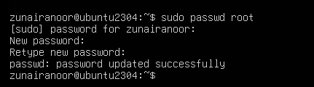

1. Switch to root and verify:

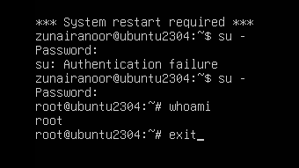

1. Switch back to your normal user:

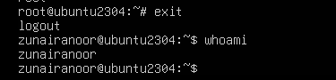

**Task 2 – Create user tom and verify in passwd/group/shadow**

Goal: Create a user named tom, then verify the account in system files.

1. Create user tom (interactive, sets password and home directory):

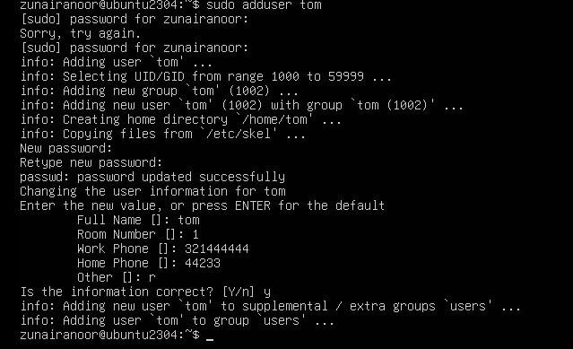

1. Verify tom in system files (view and visually confirm presence):

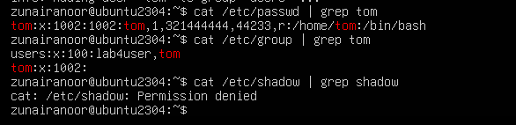

**Task 3 – Create groups; change tom’s primary and secondary groups**

Goal: Create groups developer, devops, and designer. Change tom’s primary group and manage secondary groups.

1. Create groups and verify by viewing /etc/group (visually confirm entries exist):

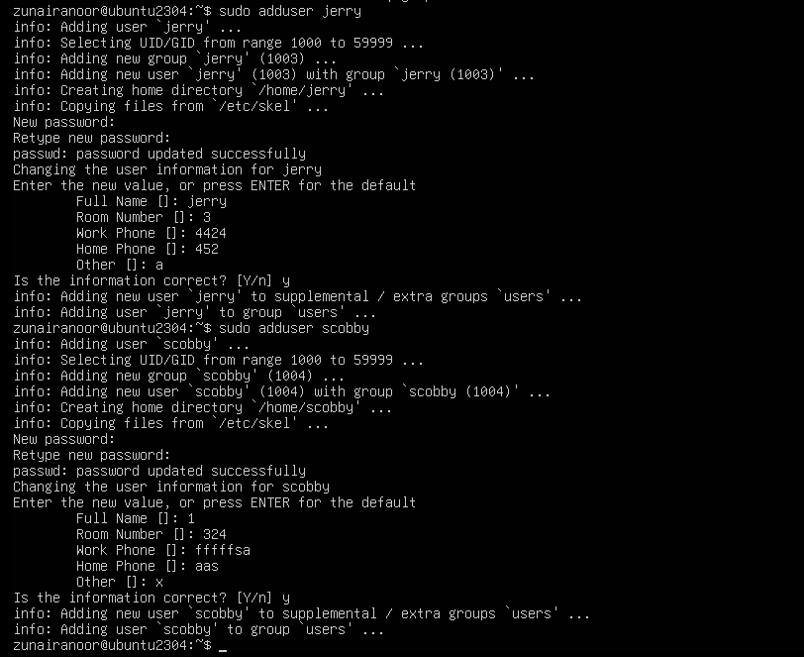

1. Change tom’s primary group to designer and verify:

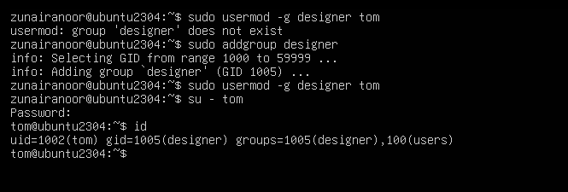

1. Add secondary groups developer and devops to tom and verify:

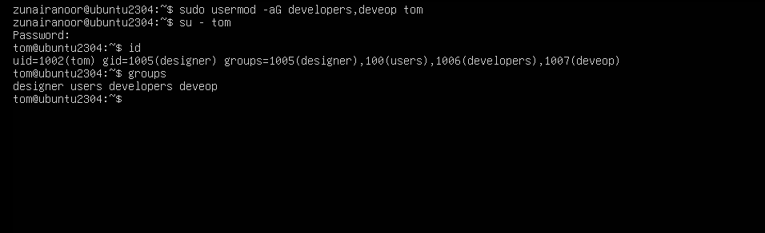

1. Replace all secondary groups so only tom (user’s own group) remains and verify:

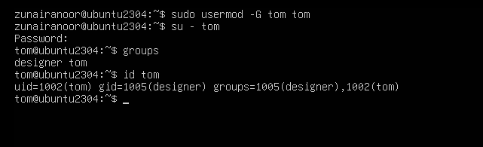

**Task 4 – Create/delete users (Jerry, Scooby) and groups (jolly, anime)**

1. Create users:

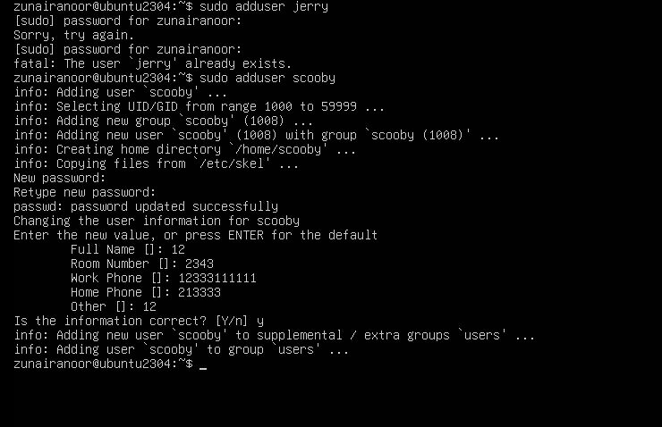

1. Try to log in as Scooby immediately (expected authentication failure because there is no password yet):
2. 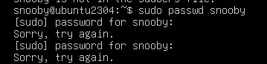
3. Set a password for Scooby:

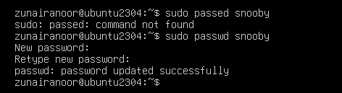

1. Try logging in as Scooby again (home directory still missing; expect a message such as “No directory, logging in with HOME=/”):

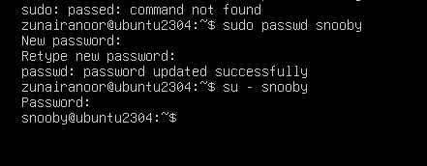

1. Show that Scooby’s home directory does not exist yet and what /etc/passwd says:

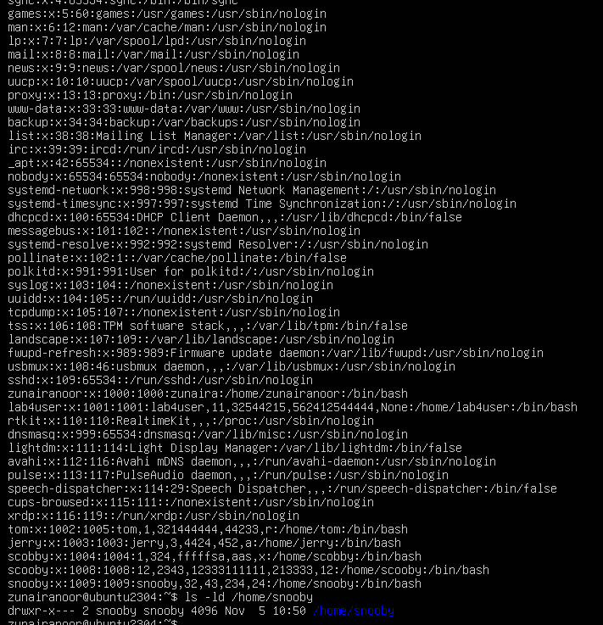

1. Manually create Scooby’s home directory and set proper ownership and permissions:

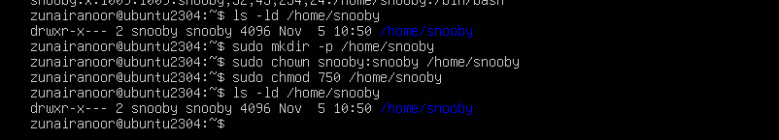

1. Log in as Scooby again and verify you land in the correct home directory:

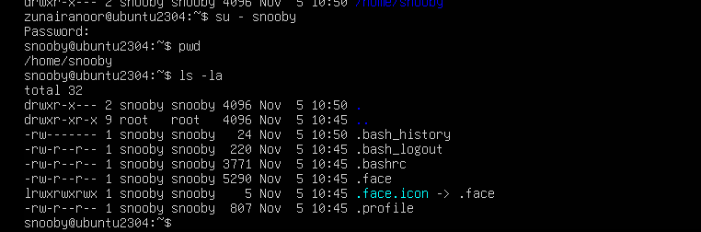

1. Verify users in system files and observe shell of Scooby:

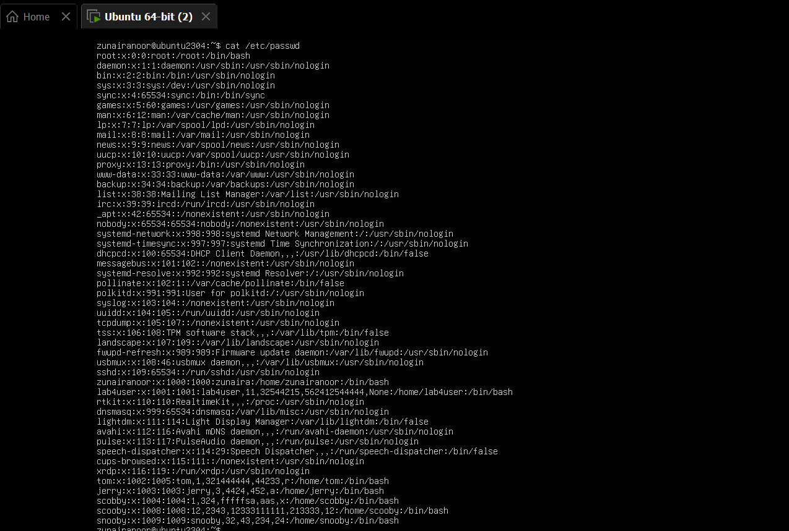

1. Create groups:

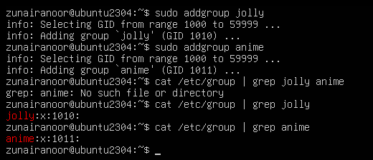

1. Verify groups:



1. Delete groups and users:

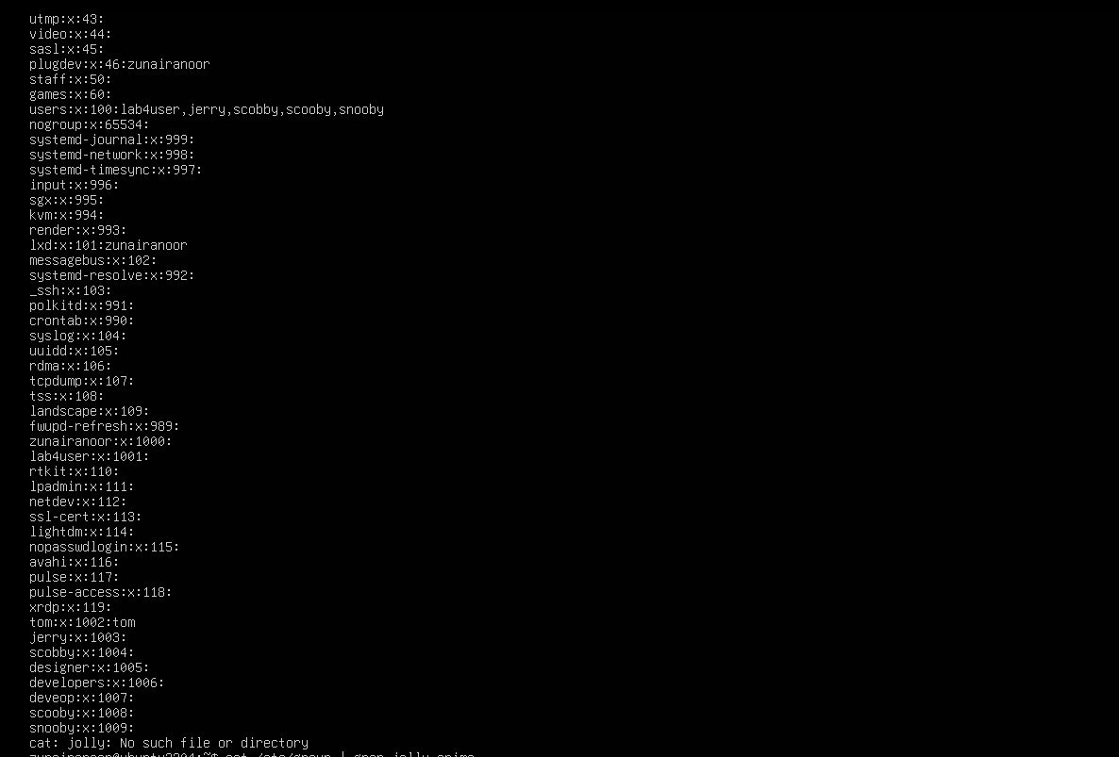

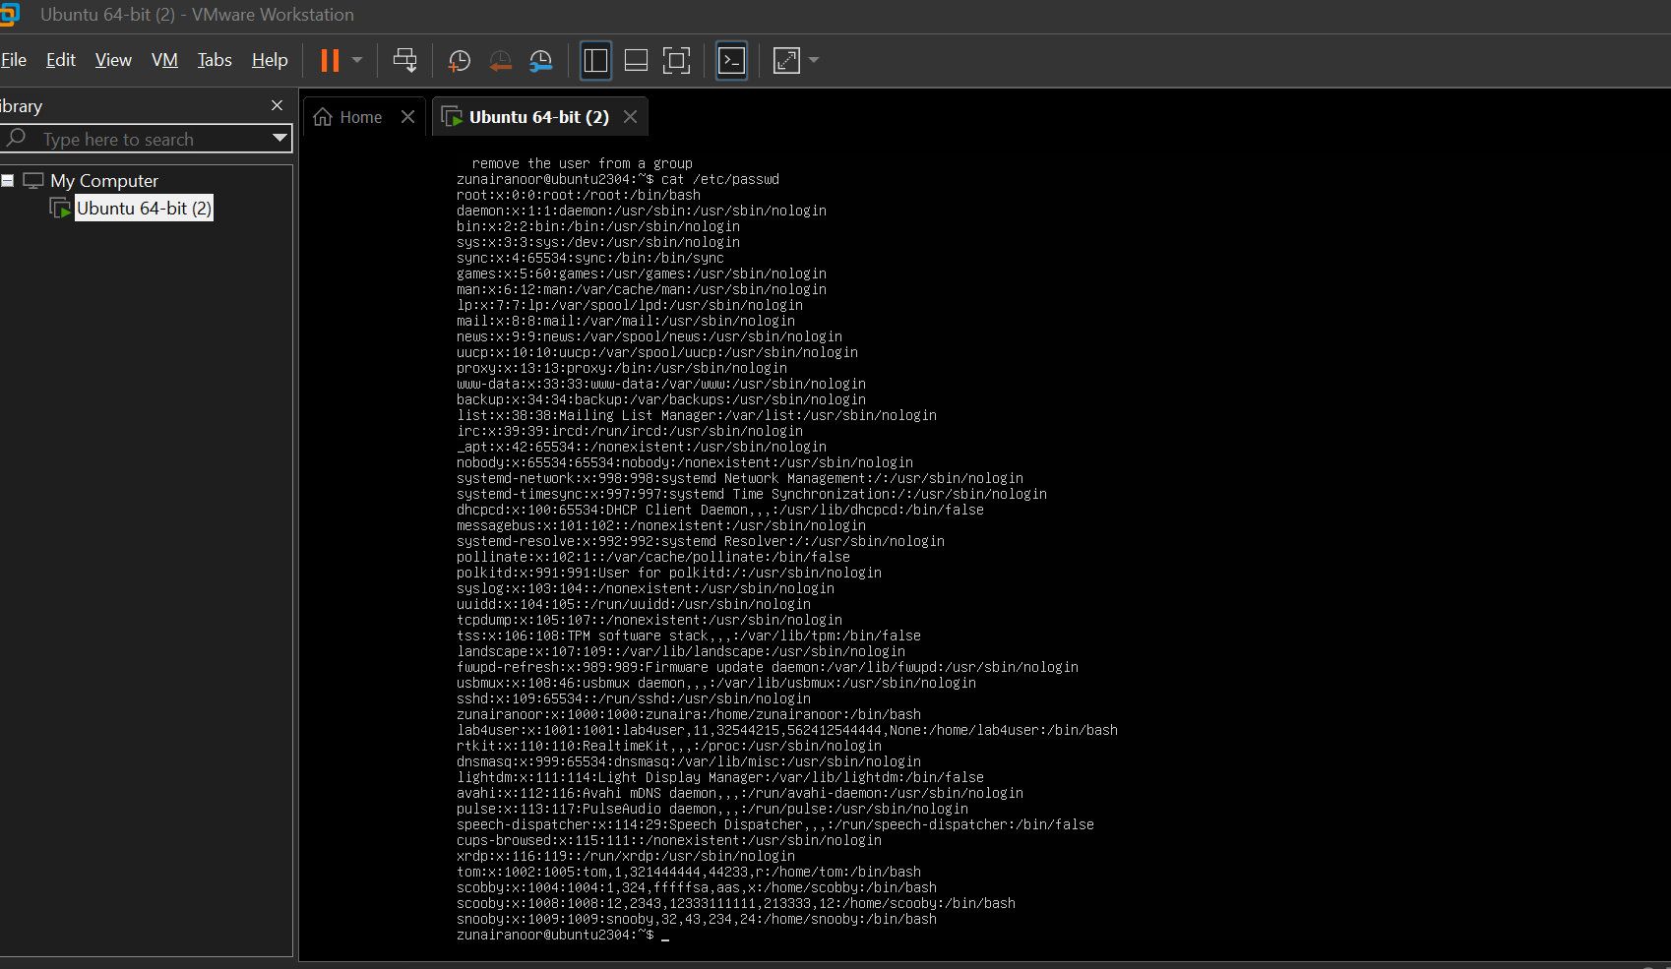

**Task 5 – Create user Student; create files; set owner/group; identify file types**

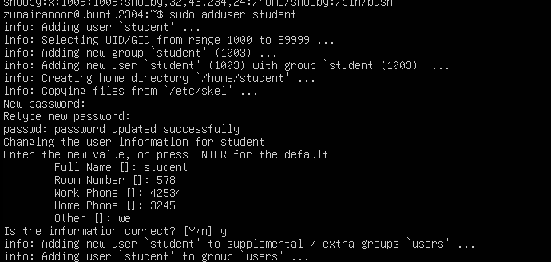

1. Switch to Student and create files:

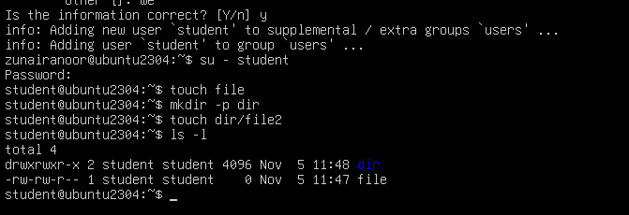

1. Change owner then group for file1 (separate commands):

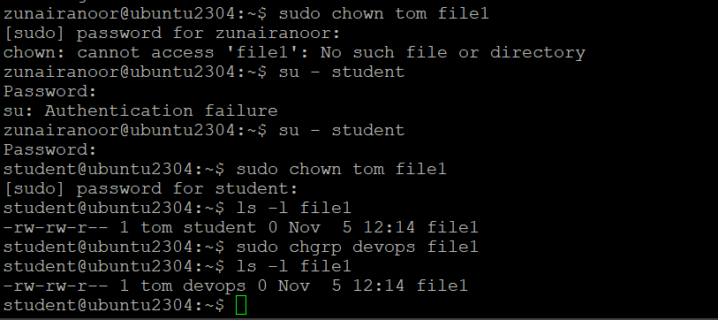

1. Identify files/directories and show /dev/null:

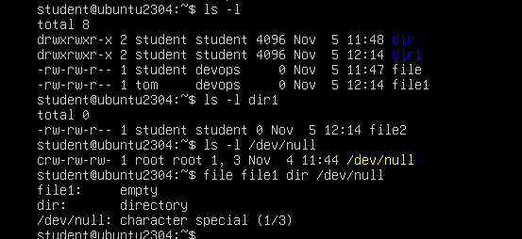

1. Exit Student:

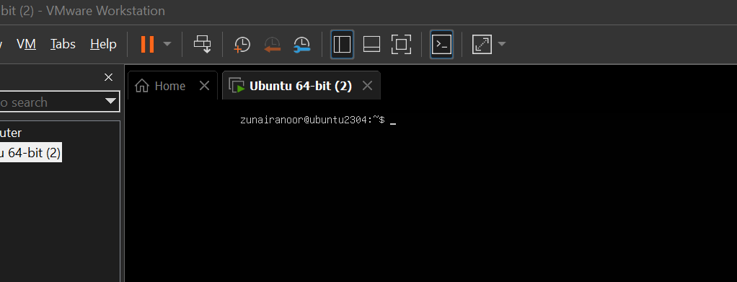

**Task 6 – Change permissions using symbolic mode**

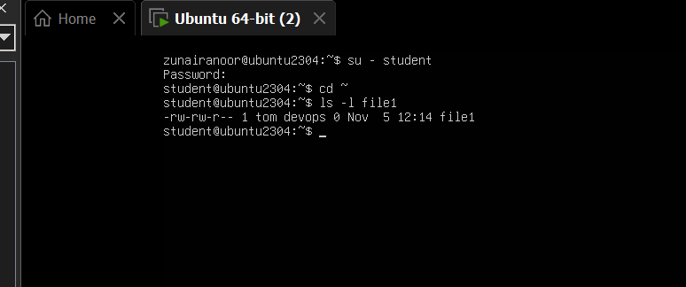

1. Remove all permissions:

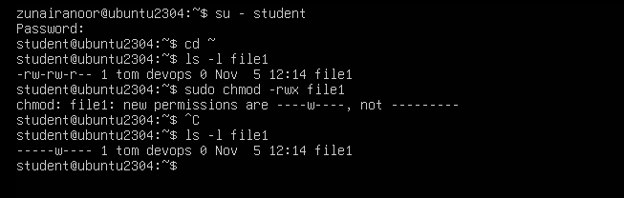

1. Add read to all:

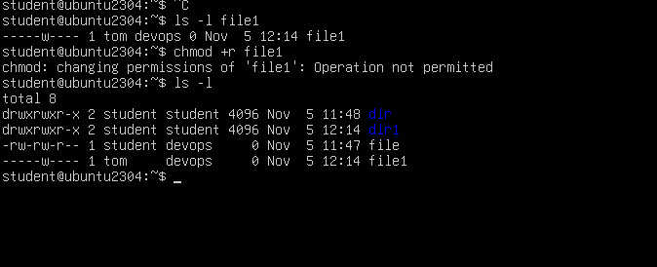

1. Add execute to user:

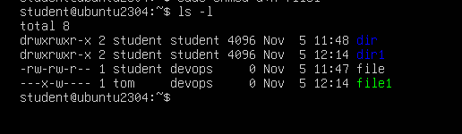

1. **Add write to user and group:**

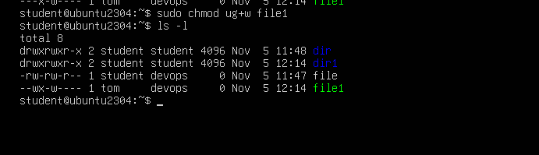

1. **Remove all permissions (explicit):**

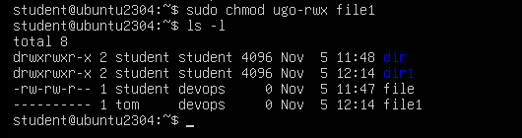

**Task 7 – Change permissions using “set” symbolic form (u= g= o=)**



1. **Remove execute from group and others:**



1. **Remove all permissions:**

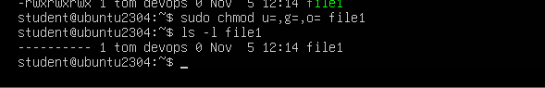

**Task 8 – Change permissions using numeric (octal) mode**



**chmod 777 file1**



**chmod 700 file1**



**chmod 744 file1**



**chmod 640 file1**



**chmod 664 file1**



**chmod 775 file1**



**chmod 750 file1**

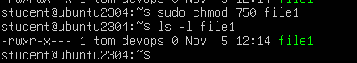

**Task 9 – Practice pipes, pagers, grep, and redirects with /var/log/syslog**

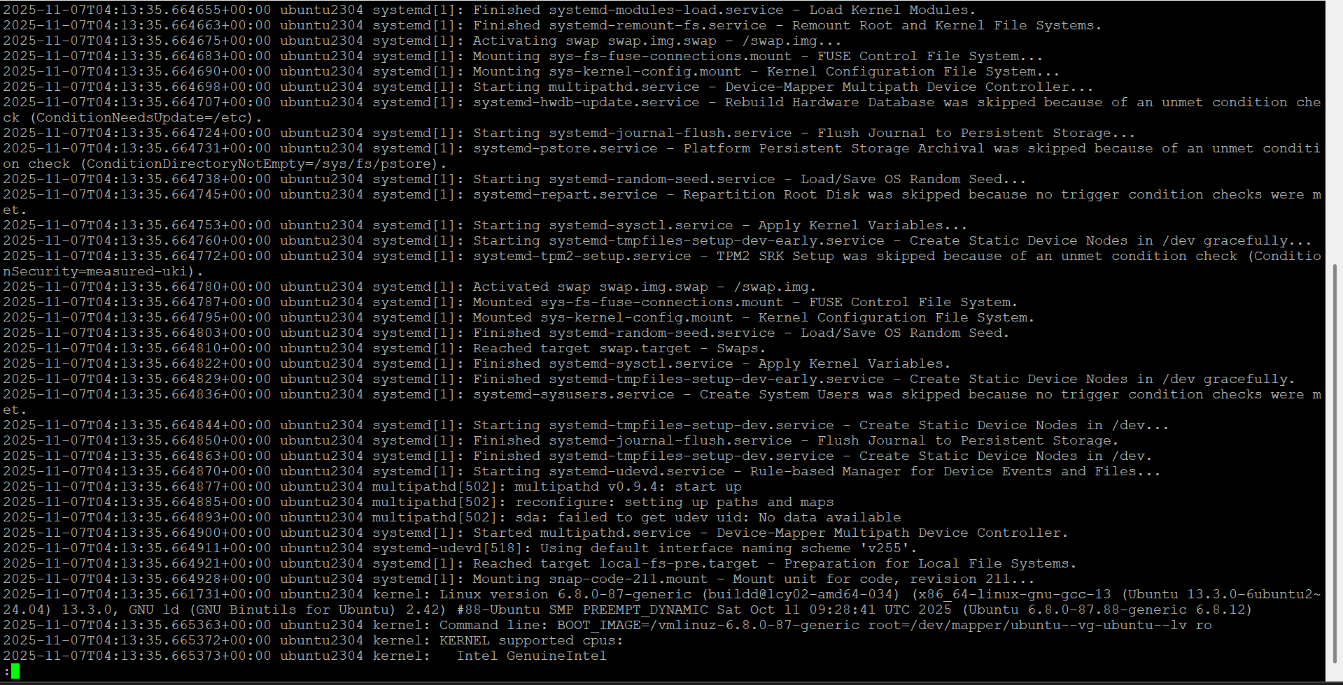

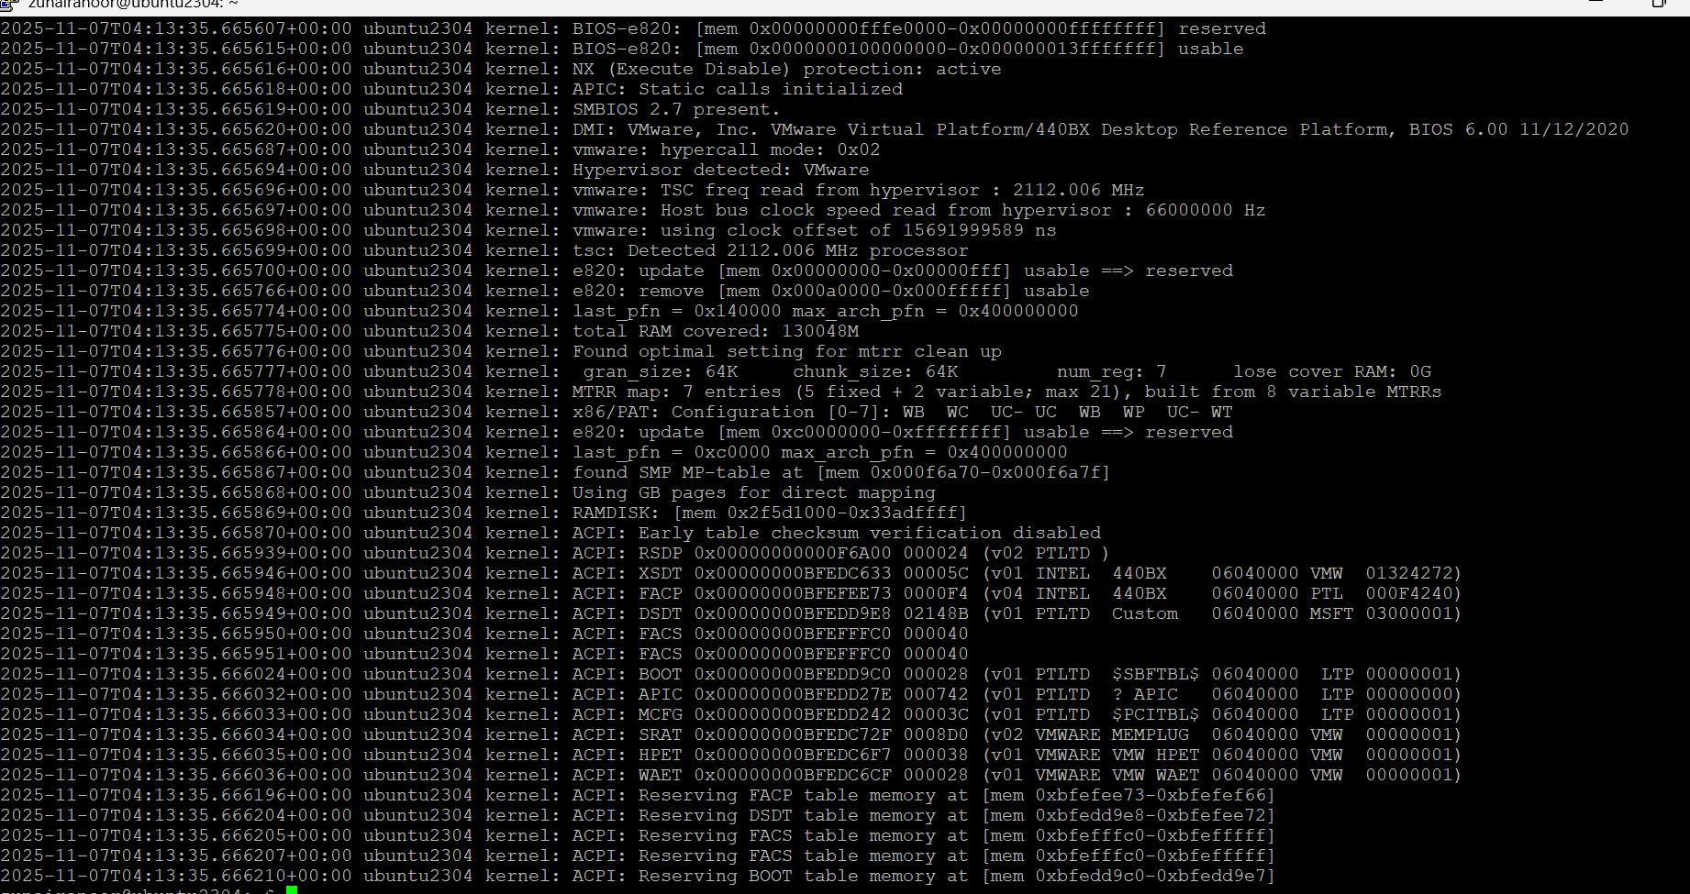

1. grep failures/errors:



1. redirect:



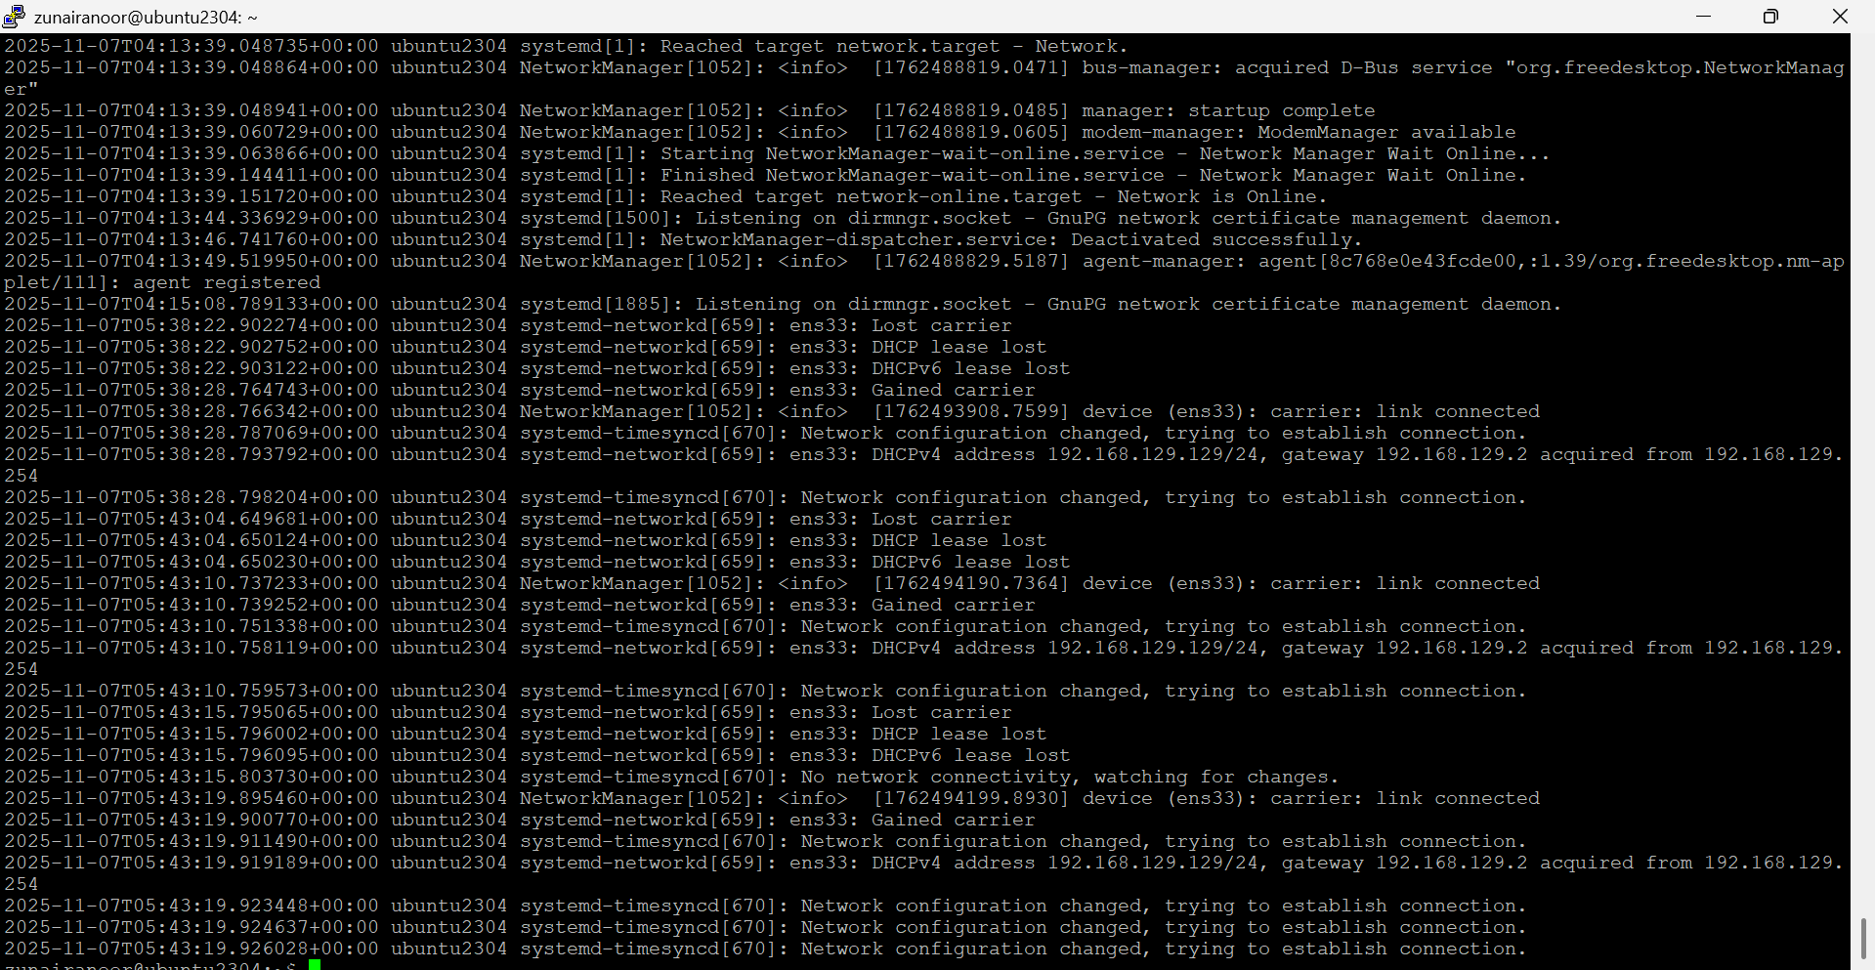

**Task 10 – Script setup.sh – variables, command substitution, file/dir checks, permissions (use vim)**

Make executable with:

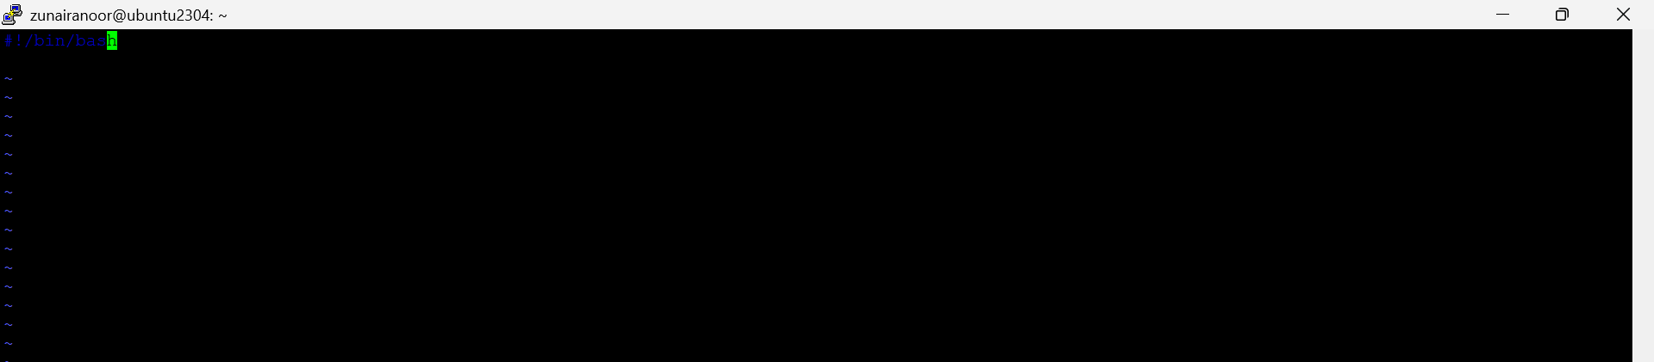

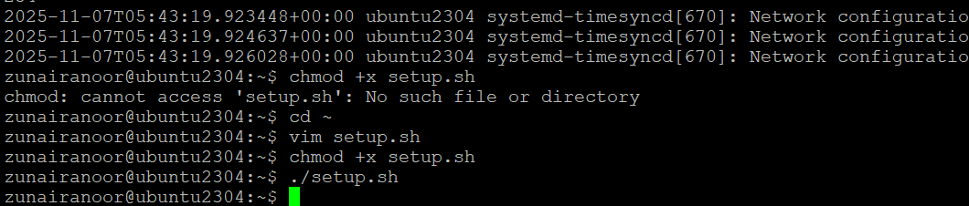

**Step 2 – Define variable var1 and echo it**

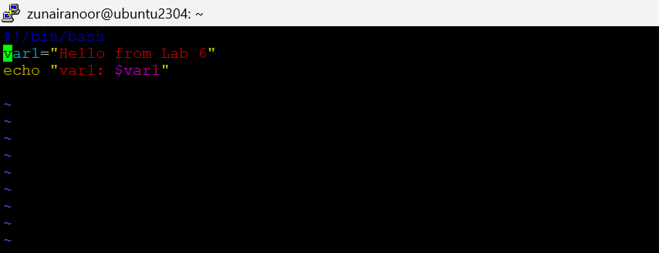

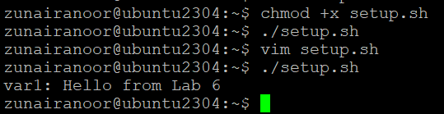

Step 3 – Save output of ls -l into variable allFiles and echo it

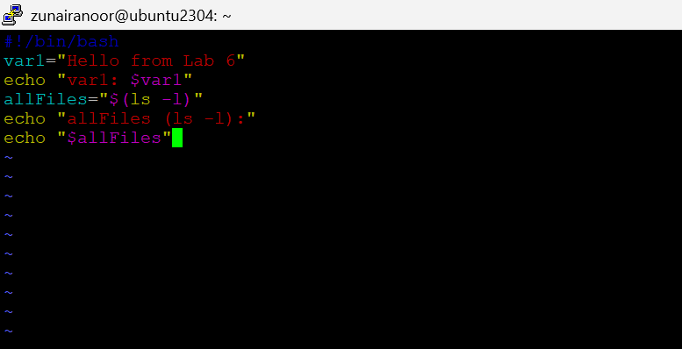

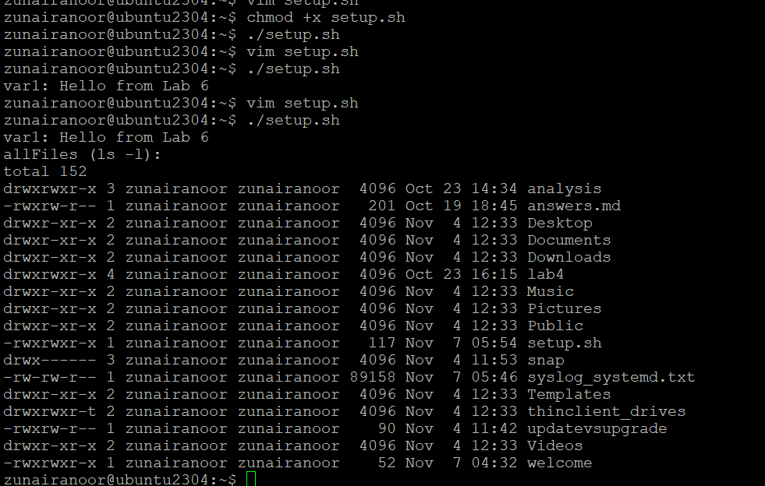

Step 4 – Directory check (dir1)

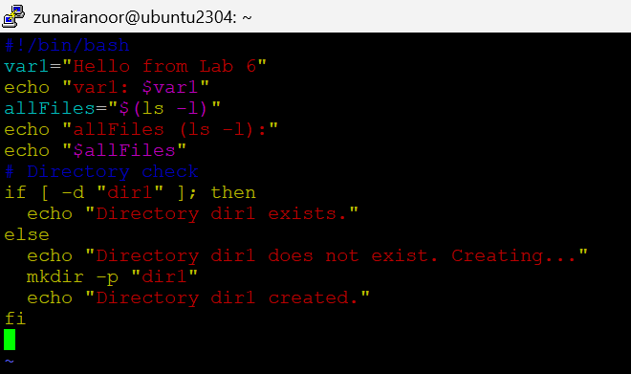

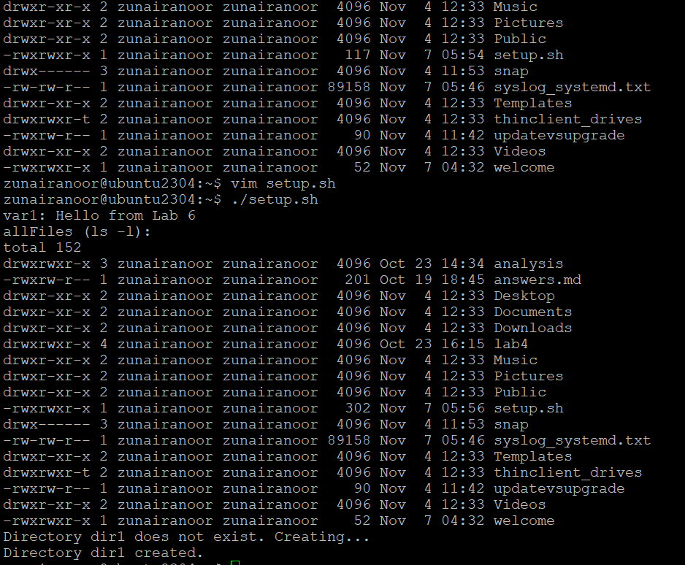

**Step 5 – File check (dir1/file2)**

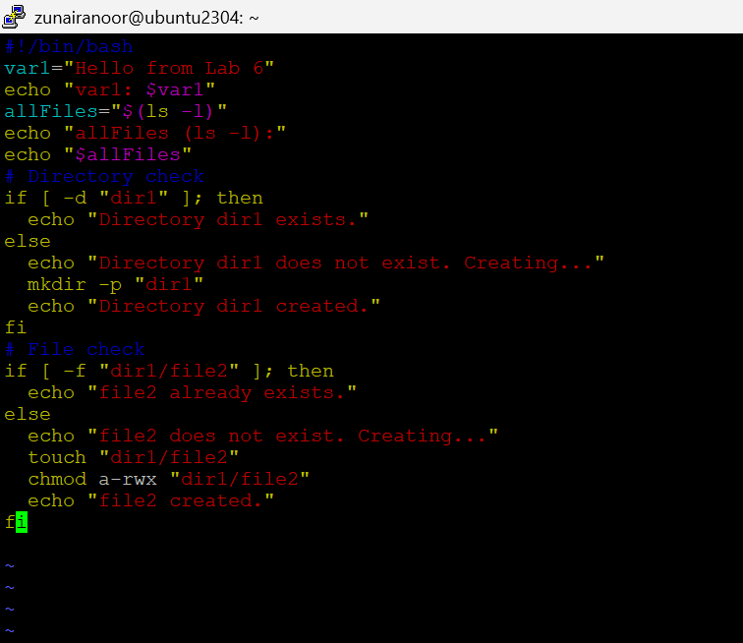

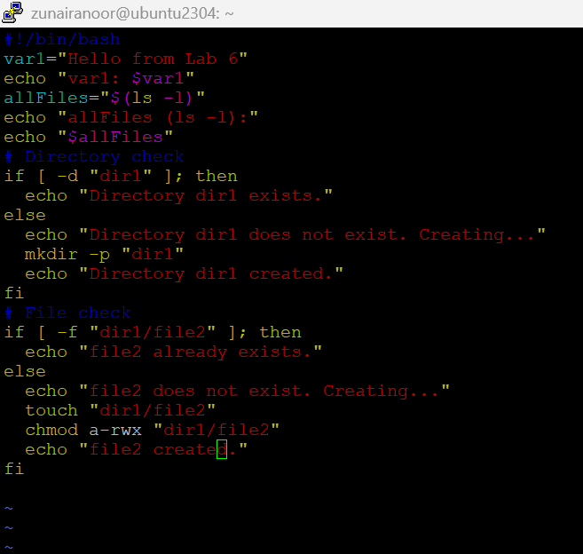

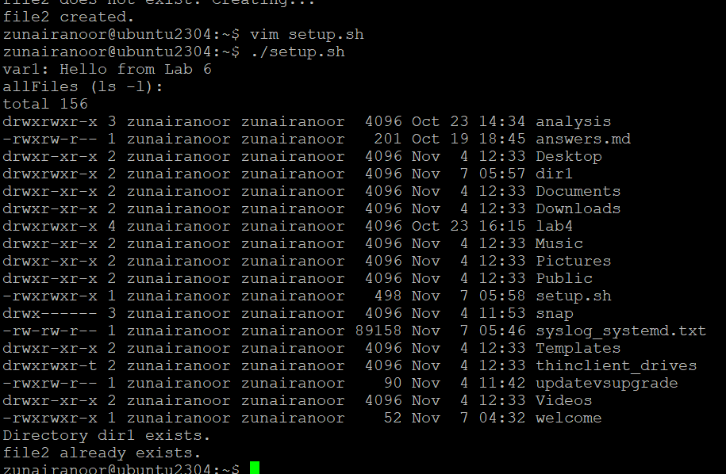

**Task 11 — Argument Comparisons**

**🔹 Step 0 — Create file and define variables**

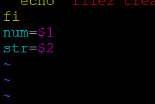

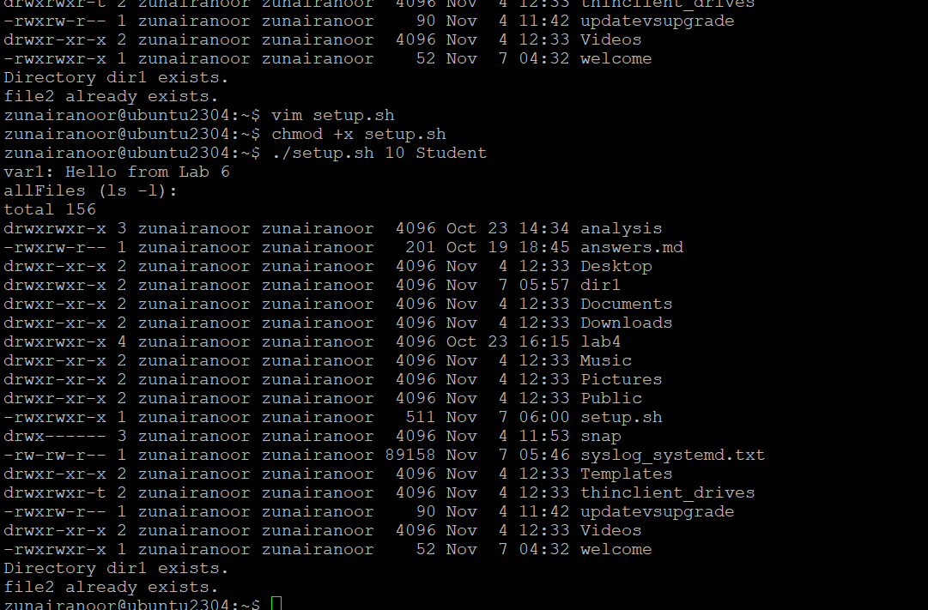

**🔹 Step 1 — -eq (equal)**

**Append:**

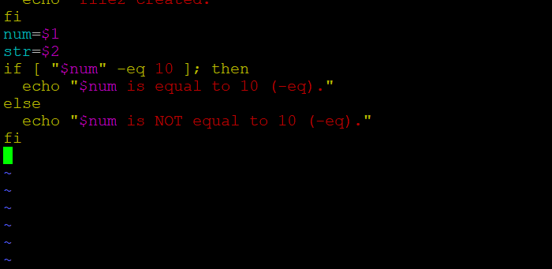

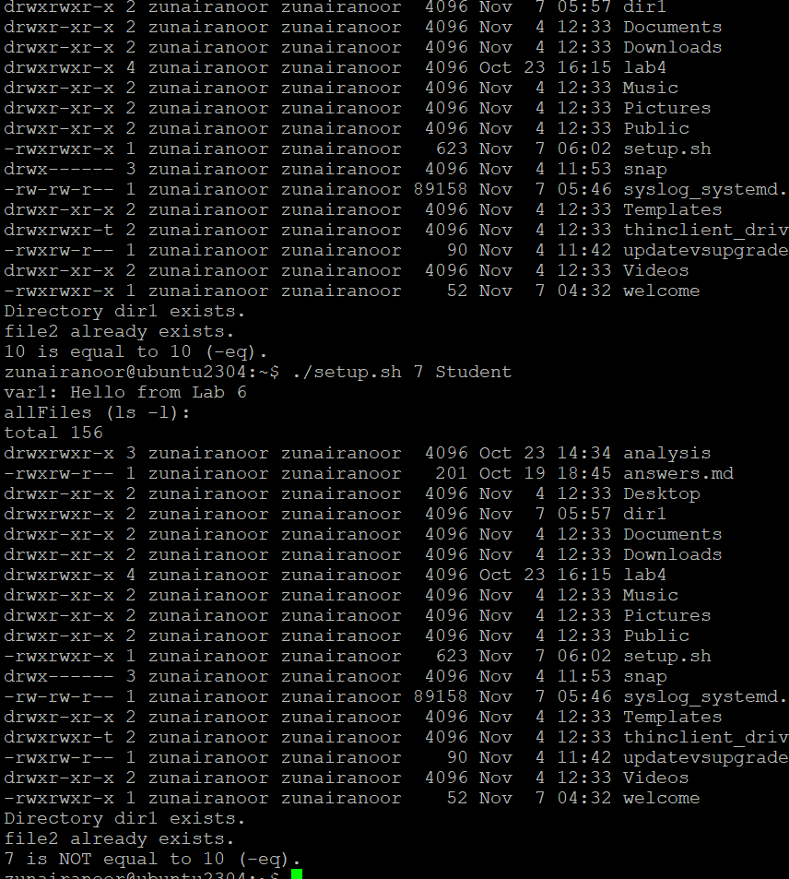

**Step 2 — -ne (not equal)**

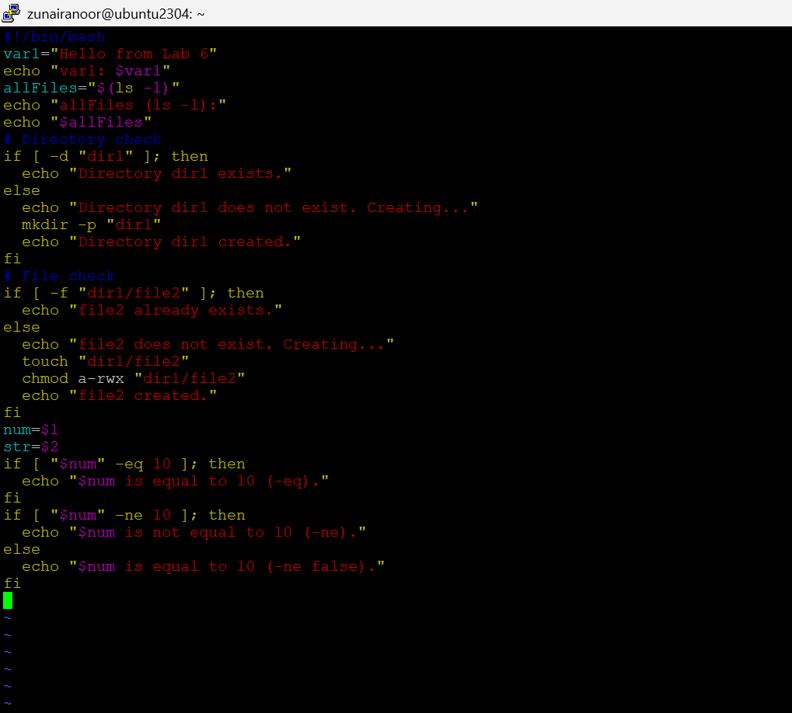

**Step 3 — -gt (greater than)**

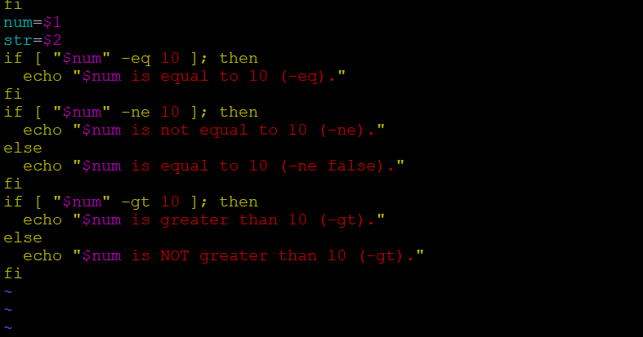

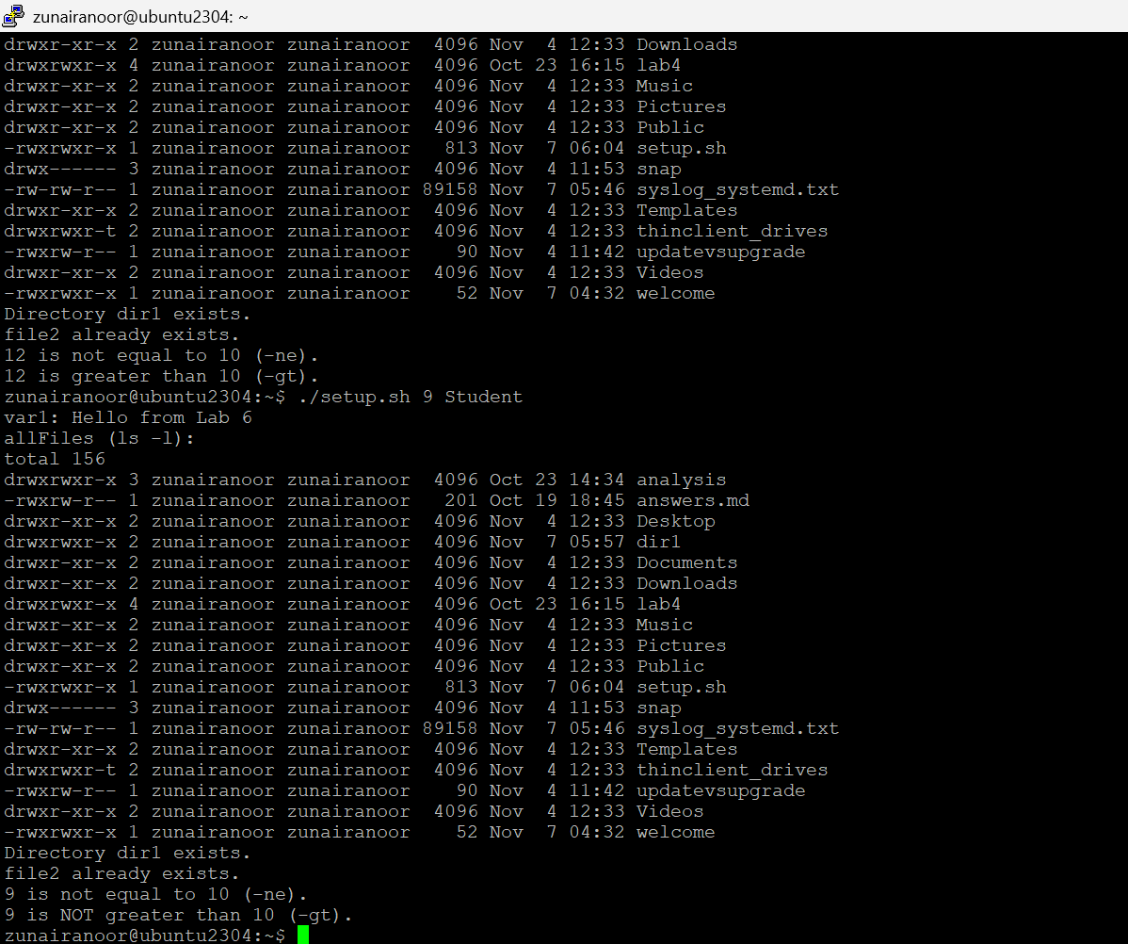

**🔹 Step 4 — -lt (less than)**

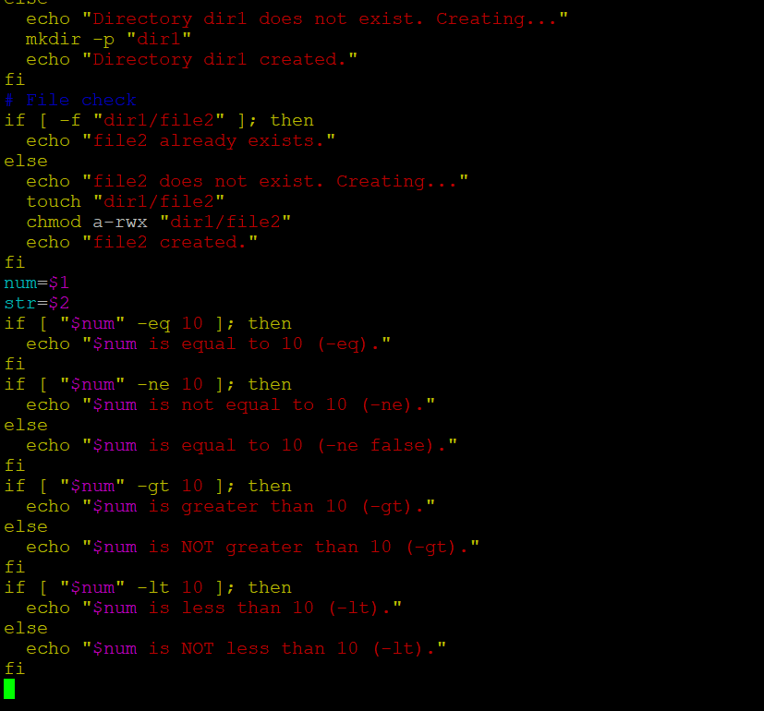

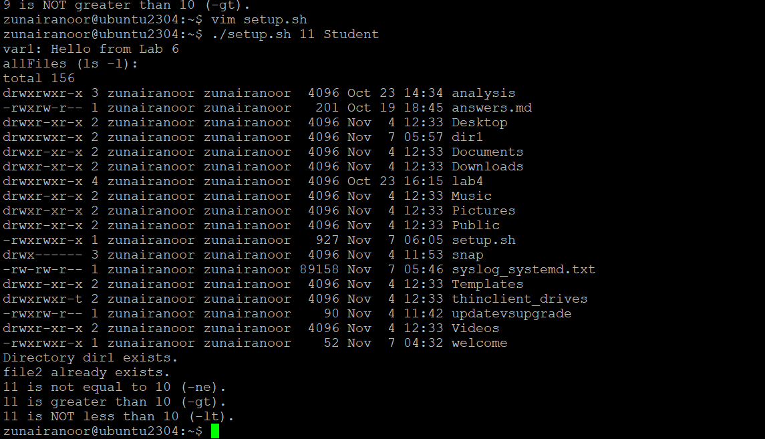

**Step 5 — -ge (greater or equal)**

**Append:**

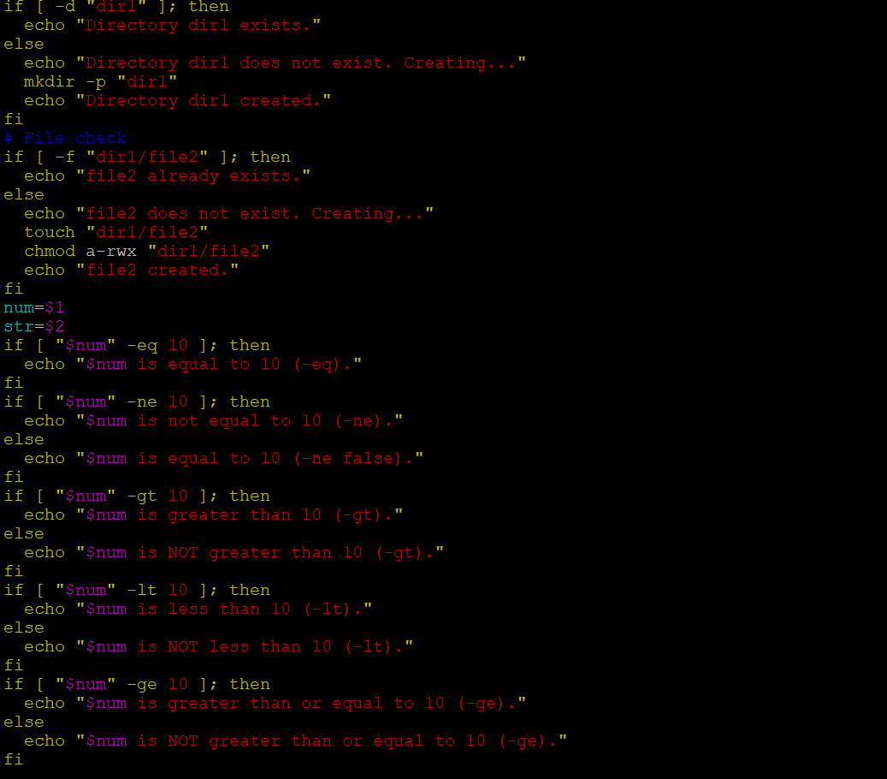

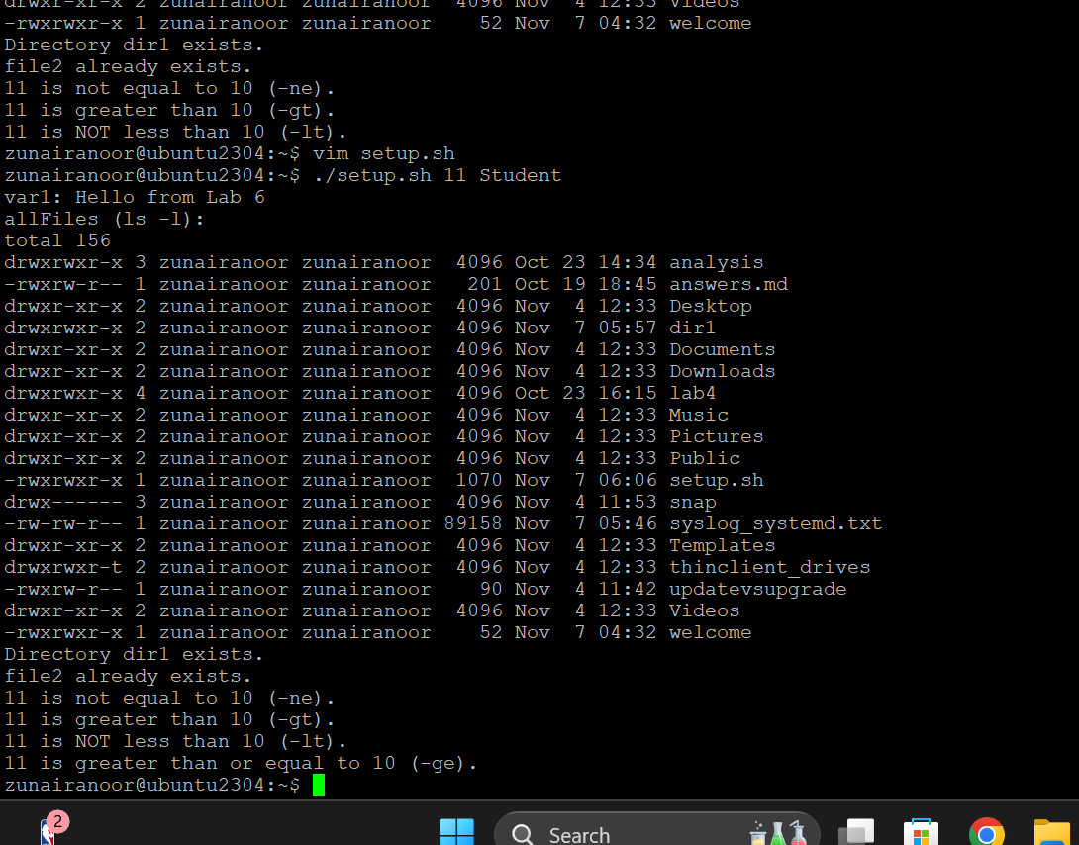

**Step 7 — String equality =**

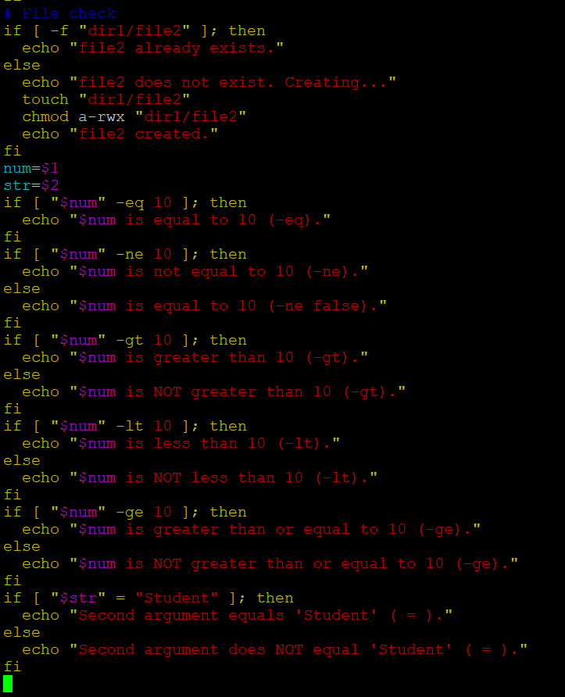

**Step 8 — String inequality !=**

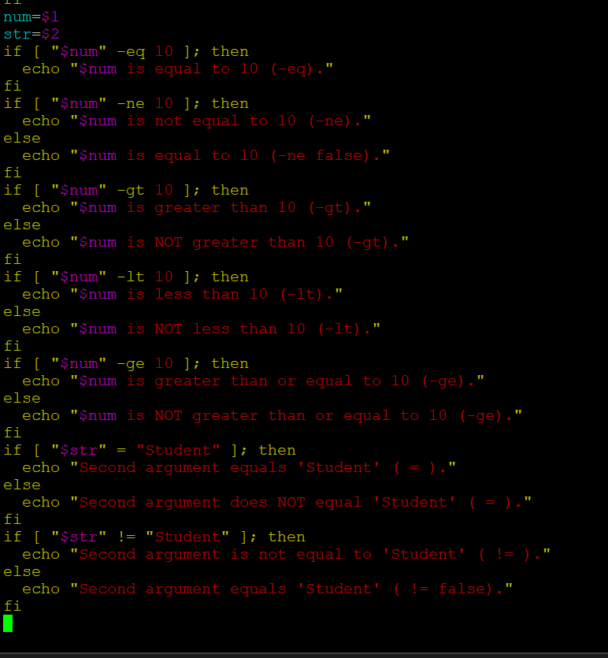

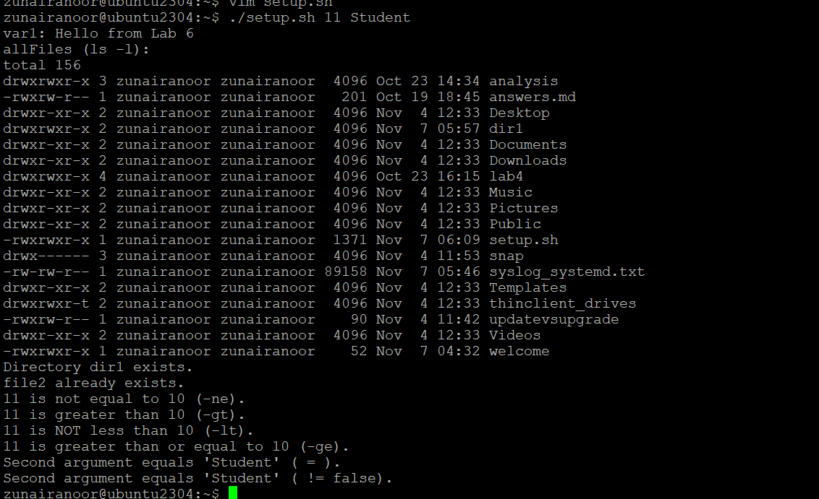

**Step 9 — Check empty string -z**

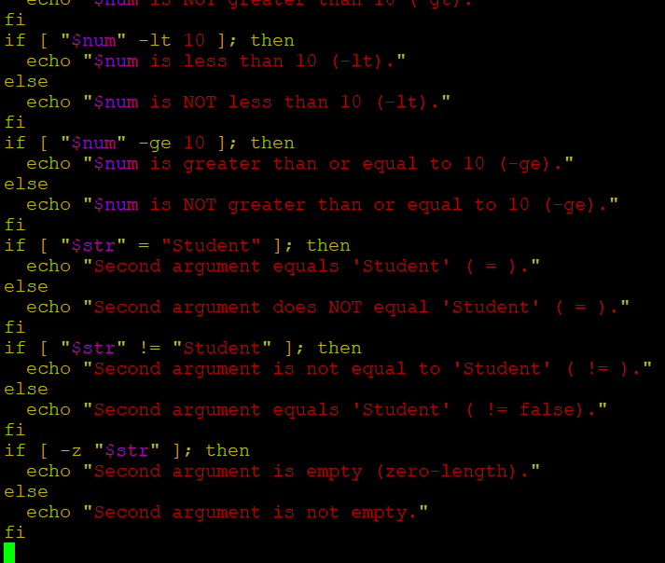

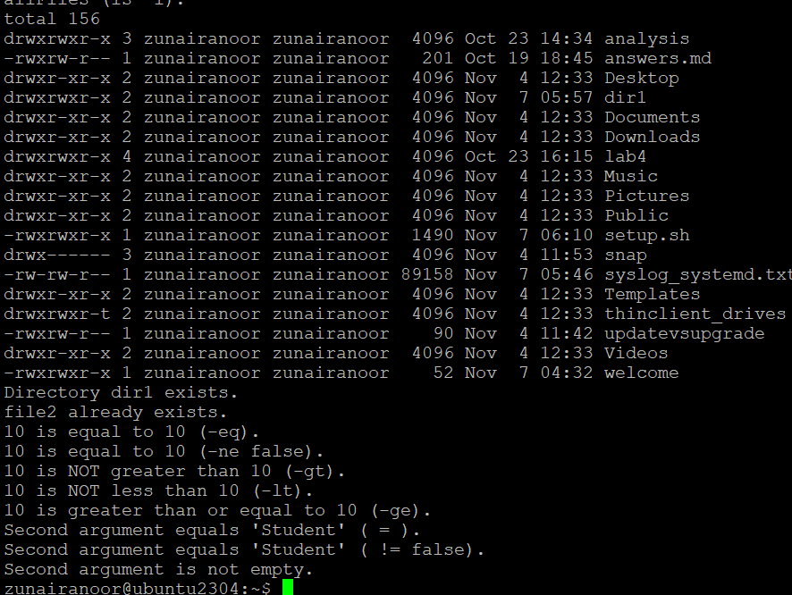

**Task 13 – setup.sh – While Loop Summation and Functions**

**🔹 Step 1 – Shebang only**

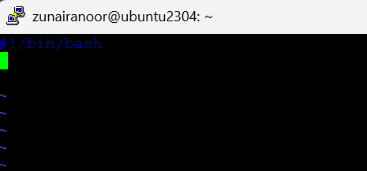

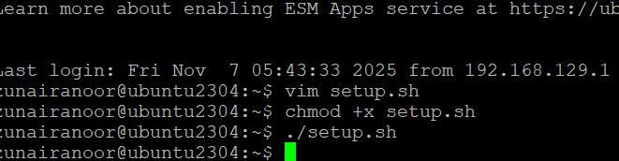

**Step 2 – Interactive While-Loop Summation**

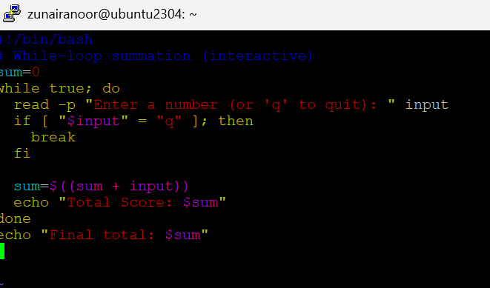

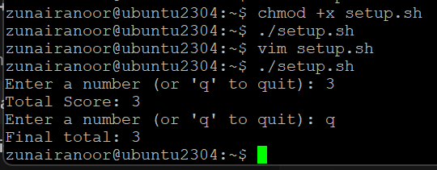

**Step 3 – Move into a Function (sum_two)**

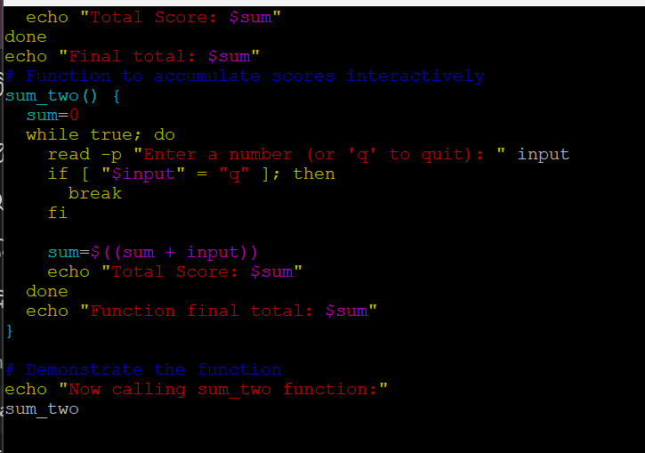

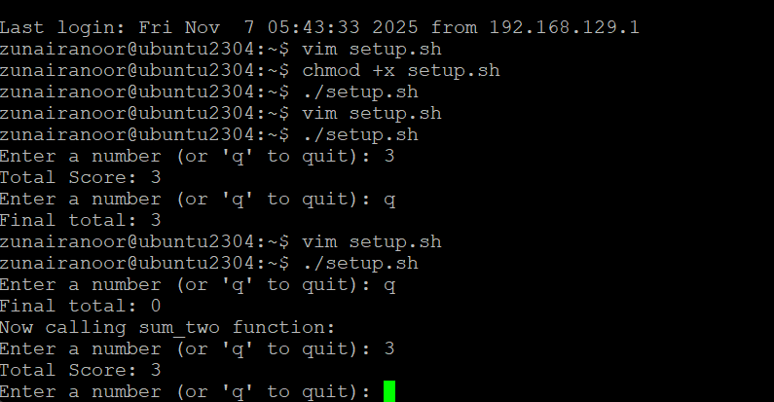

**Step 4 – Function with Two Numeric Arguments**

